PRACTICAL 6
Q. Create a client-server application using Named Pipes (FIFOs). The client sends messages and the server processes and responds to them. Analyze FIFO behavior when multiple clients communicate simultaneously. Create a POSIX signal handling program that captures SIGINT, SIGTERM, and SIGUSR1. Demonstrate asynchronous event handling and explain the role of signal handlers.
1. SERVER.C
#include <stdio.h>
#include <stdlib.h>
#include <string.h>
#include <unistd.h>
#include <fcntl.h>
#include <sys/stat.h>

#define FIFO1 "client_to_server"
#define FIFO2 "server_to_client"

int main() {
char buffer[100];
int fd1, fd2;

mkfifo(FIFO1, 0666);
mkfifo(FIFO2, 0666);

printf("Server started...\n");

while (1) {
fd1 = open(FIFO1, O_RDONLY);
read(fd1, buffer, sizeof(buffer));
close(fd1);

printf("Server received: %s\n", buffer);

char response[120];
sprintf(response, "Processed: %s", buffer);

fd2 = open(FIFO2, O_WRONLY);
write(fd2, response, strlen(response)+1);
close(fd2);
}
return 0;
}
2. CLIENT.C
#include <stdio.h>
#include <stdlib.h>
#include <string.h>
#include <unistd.h>
#include <fcntl.h>

#define FIFO1 "client_to_server"
#define FIFO2 "server_to_client"

int main() {
char buffer[100];
int fd1, fd2;

printf("Enter message: ");
fgets(buffer, sizeof(buffer), stdin);

fd1 = open(FIFO1, O_WRONLY);
write(fd1, buffer, strlen(buffer)+1);
close(fd1);

fd2 = open(FIFO2, O_RDONLY);
read(fd2, buffer, sizeof(buffer));
close(fd2);

printf("Client received: %s\n", buffer);

return 0;
}
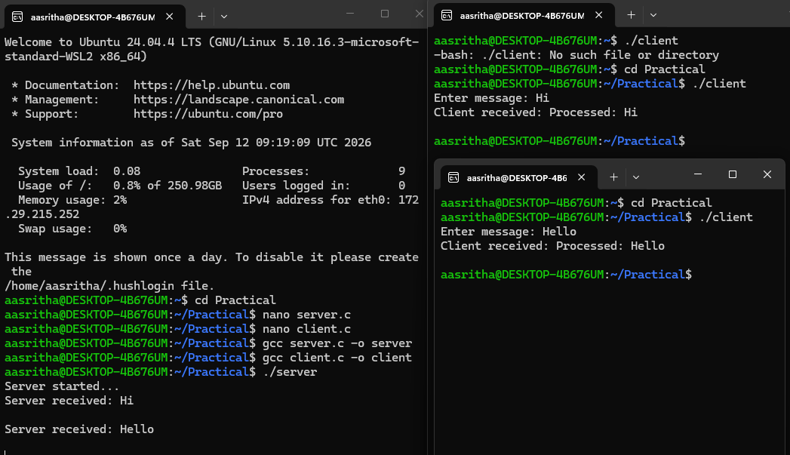

3. signals.c
#include <stdio.h>
#include <stdlib.h>
#include <signal.h>
#include <unistd.h>

void handler(int sig) {
if (sig == SIGINT)
printf("Caught SIGINT (Ctrl+C)\n");
else if (sig == SIGTERM)
printf("Caught SIGTERM (termination request)\n");
else if (sig == SIGUSR1)
printf("Caught SIGUSR1 (user-defined signal)\n");
}

int main() {
signal(SIGINT, handler);
signal(SIGTERM, handler);
signal(SIGUSR1, handler);

printf("Program running... PID=%d\n", getpid());

while (1) {
pause(); // wait for signals
}
return 0;
}
